Nottingham Little League
Fall 2021 – Summer 2022

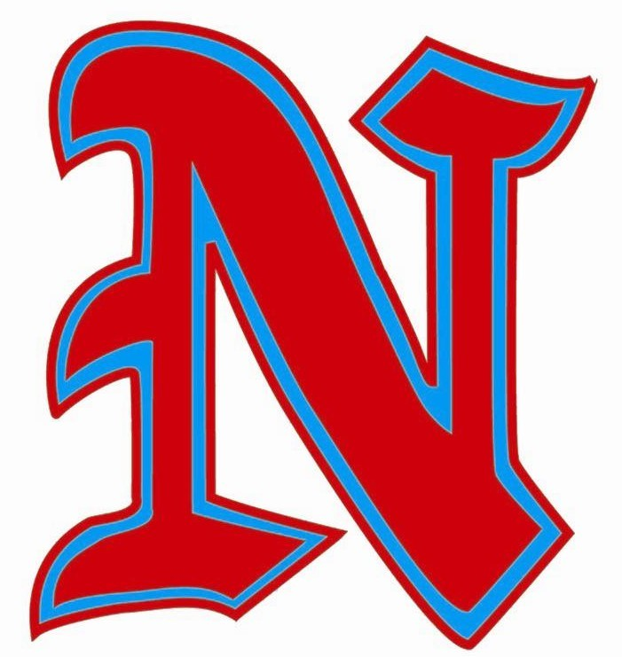

Indoor Facilities Plan

Nottingham Little League (NLL) has prepared the following guidelines for the Fall 2021 – Summer 2022 season for the use of the NLL indoor facilities (batting cages) based on the requirements provided by the New Jersey Department of Health. These guidelines must be adhered to by all who enter and use the cages.
NLL indoor batting cages (Big Cage and Small Cage) will be open to those who request and receive permission from NLL to use them and accept these guidelines.
- All indoor practices and competitions may resume with the following guidelines, including limitations on attendance:
  - TEAM PRACTICES and CLINICS:
    - It is the responsibility of the coach/instructor in charge to ensure the following guidelines are met.
      - All coaches/players must be informed that anyone who does not feel well should stay home
      - All coaches/players must be informed that a COVID-19 pre-screening health check must be completed for all participants before every practice/session
      - A list of all who attend each practice/session (coaches and players) must be kept (and maintained for a minimum of 2 weeks) and be available to the league if required
      - Parents are NOT permitted inside the batting cage facility during team practices or clinics at this time

  - PRIVATE LESSONS:
    - It is the responsibility of the instructor in charge to ensure the following guidelines are met.
      - Communication must be provided to their clients emphasizing that anyone who does not feel well should stay home
      - A health check should be completed for all participants before every session
      - A list of all who attend each session (instructors/coaches and players) must be kept (and maintained for a minimum of 2 weeks) and be available to the league if required
      - 1 parent/guardian per family is permitted inside the batting cage as a spectator (private lessons only)
- PLEASE NOTE:
  - If a coach or player has been asked to quarantine outside of NLL (for example, per their school's guidelines), then NLL expects that the same quarantine protocol be applied to their participation at Nottingham Little League.

